Low Carbohydrate Diet

**What is a low Carbohydrate Diet?**

A **low Carbohydrate Diet** has less than **130 grams** of carbohydrate per day. It is sometimes referred to as **LCHF** (or low carbohydrate, high fat) diet.

What is Carbohydrate?

Carbohydrate is collective name for sugars and starches.

Sugars mainly exist as sucrose (table sugar), glucose (often found in sweets and processed foods), fructose (fruit sugar) and lactose (dairy sugar). These usually taste sweet.

Starches (bread, potatoes, pasta, rice etc) are made of long chains of glucose, which the body rapidly digests into blood glucose. Starches often do not taste so sweet, and so it’s not obvious that starches contain lots of glucose.

The body quickly digests carbohydrates into blood glucose.

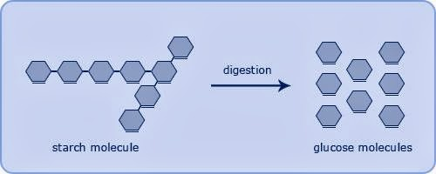

To stop blood glucose rising too high the body releases the hormone insulin. Insulin tells the liver and muscles to take glucose out of the blood, and into storage. Once the liver and muscles are full of stores, insulin tells the body to turn any extra blood glucose into fat stores.

Being in a state of excess insulin, with full stores of glucose can lead to high blood pressure, high cholesterol, fatty liver disease, central obesity. This can progress to pre-diabetes and then Type 2 Diabetes which is a state of constantly high blood glucose.

A very effective way of reversing this state is to reduce overall carbohydrate (sugar and starch) intake. It is not essential to eat carbohydrate as the body can turn both fat and protein into blood sugar. **Proteins and fats are essential for health, Carbohydrates are not.**

It is a really useful way to treat conditions like Diabetes, high blood pressure, obesity, fatty liver and polycystic ovaries without additional medications.

**Are there any side effects?** As the body adapts to a low carbohydrate diet some people experience a mild headache for a few days, constipation can occur (but tends to improve with time). Light headedness is a sign that blood pressure is improving and some people will need to reduce blood pressure treatment. Most people find they feel less hungry than on traditional diets, and some people will need to reduce diabetes medications which actively lower glucose levels (such as gliclazide and insulin). Metformin can usually be continued as normal.

**Is it for everyone?** It can be a challenging diet for people who already miss a major food group such as vegetarians or vegans, but plenty of hints and tips are available from a wide online support network. We know that **any diet that leads to sustained weight loss** **can benefit a range of conditions** – and traditional which leads to weight loss can still be very effective.

**Isn’t eating fat bad?** Surprisingly most people who stick to a low carbohydrate diet see improvements in their cholesterol profile. Good cholesterol levels tend to rise, and bad cholesterol levels fall. This is because the body turns excess carbohydrate into a particularly harmful fat called triglyceride, and high insulin levels can reduce levels of good (HDL) cholesterol. HDL protects against heart disease and stroke.

**Sugary and Starchy Foods are converted into glucose by the body – how do I know much this will affect my blood sugar?**

Food labels are a good way to see the total carbohydrate content in foods – but look closely for the total carbohydrate content not just the sugar content

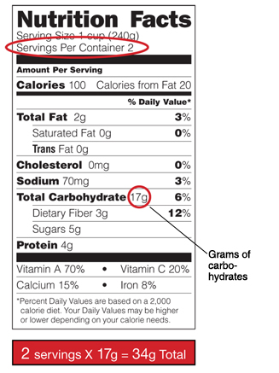

**Low Carb Diet Resources**

[www.Diabetes.co.uk](http://www.diabetes.co.uk/) has some excellent sections on low carbohydrate diets for type 2 diabetes, and a support forum for patients.

A free NHS approved app for smartphones called *‘Low Carb Programme’* is available for both Apple and Android.



*The Diabetes Weight Loss Cookbook - Katie and Giancarlo Caldesi* contains helpful low carb recipes with easy to understand graphics.

*The blood sugar diet -Dr Michael Mosley* <https://thebloodsugardiet.com/> written by a practising doctor has great suggestions and evidenced based information

[*www.dietdoctor.com*](http://www.dietdoctor.com/) Has a huge number of helpful recipe suggestions.

*Carbs & Cals*  is a reference book and App which helps to know the carbohydrate content of a huge number of different foods.

**So What Can I Eat?**

**Try aiming for less than 130g/day carbohydrate, and less than 30-40g/meal. Try and make snacks <5-10g carbohydrate.**

Suggested **breakfast options** might be eggs, tomatoes, greek yoghurt, seeds, nuts, fish or bacon. **Minimise breakfast cereals, and fruit juice.**

Try making **main meals** around meat, fish or tofu, with green or leafy vegetables (Veg that grows above the ground!). Steak, Chicken, Pork, Ham, Turkey and Tofu all have minimal effect on blood sugar.

Minimise intake of starchy carbs like rice, pasta and potatoes. Moderate amounts of full fat dairy produce such as cheese and crème fraiche can add variety and flavour to foods – but watch out for sweetened ‘fat free’ yoghurts which may be high in sugar.

Try eating foods such as cauliflower, courgette, broccoli, and pulses in preference to root vegetables.

Make **snacks** low in carbohydrates – minimise cereal bars, biscuits, cakes and muffins. Some fruits are much lower in carbohydrate content than others – apples, watermelon, strawberries, nectarines and apricots are good, but grapes and bananas have high carbohydrate content. Nuts, seeds and modest amounts of dried meat such as biltong can be useful options for snacks.

Always avoid fruits juices, smoothies and sugary fizzy drinks, especially ‘energy drinks’– check the labels carefully for sugar –even fruit sugar!

|  |  |
| --- | --- |
| **Minimise** consumption of these foods | **Eat more of these foods** which have a much lower effect on blood sugar levels |
| Sugar, pastries, cakes, biscuits, crisps  Cereals  Bread  Potatoes  Rice  Pasta  Root Vegetables  Bananas, Grapes and tropical fruits  Smoothies and Fruit Juices  Milk chocolate, white chocolate  Ice cream  Dried fruit such as raisins and dates  *Beware of low fat foods which have been sweetened with sugar – such as low fat yoghurts*  Fizzy drinks which contain sugar, such as Coca Cola | Eggs  Non-processed meat such as chicken, fish, beef, pork, turkey  Full fat (non sweetened) Dairy such as greek yogurt  Nuts  Seeds  Pulses, Whole Beans, Avocados  Green Vegetables, and other vegetables which grow above the ground  Cauliflower, Courgettes  Tofu  Apples, Watermelon, strawberries, raspberries  Small portions of high cocoa content dark chocolate  Sugar free cordial, Zero-sugar drinks |

**How Do Common Foods Affect Blood Sugar Compared to the Effect of Table Sugar?**

*These simple graphics how much blood sugar is made from common foods*

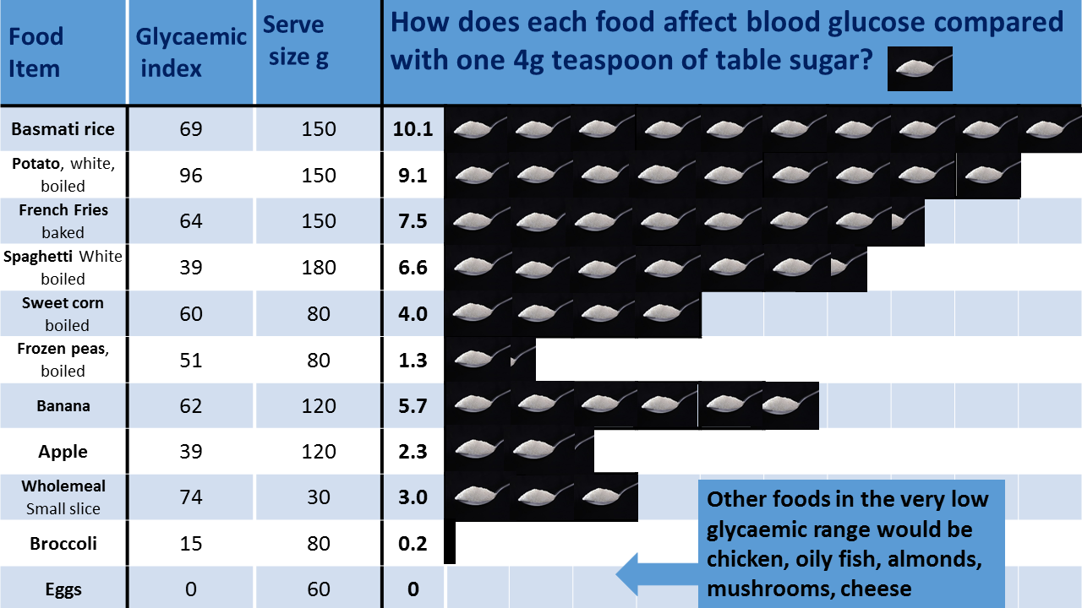

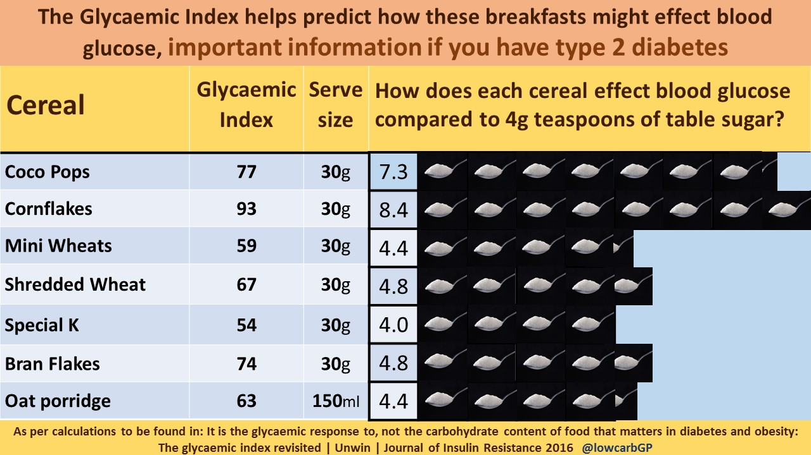

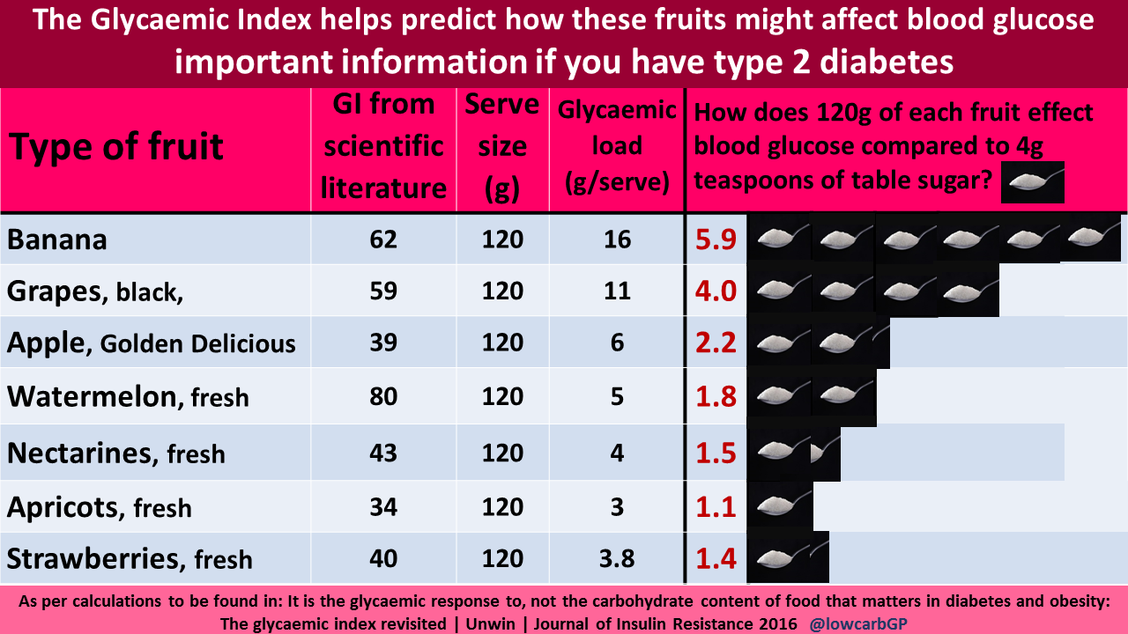[1]

1. Low Carb Info V3 - Dr C Metcalfe 2019. Thanks to Dr David Unwin for his sugar infographics