**Who we work with**

And many more!

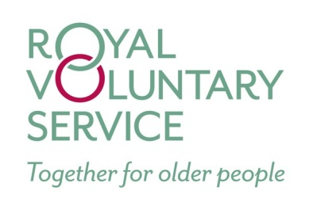

**How can we help you?**

If you are living with a medical condition and require some additional support – whatever it is – we are here to help.

Equally, if you are a carer for somebody else, we are available to help both you, and the person you care for.

Finding the right support can be a difficult and daunting task. We can help you find the right path to follow by providing information on local services.



**Who are we?**

We are **your** care co-ordinators and we are here to help **you**. Our aim is to ensure you feel supported and have access to the services that are right for you.

To give you an idea of how we can help, some of the things we have done recently are:

* Arrange for volunteers to visit patients at home, take them shopping, or for just a cup of tea and a chat!
* Refer carers to specialist support to help them look after their loved ones
* Telephone patients after discharge from hospital to ensure they have the support they need
* Put patients in touch with an optician who has experience of patients with additional needs

**What Next?**

If you would like a chat to find out more about what we can help with please just ask for the care co-ordinators at reception, or by telephone.

All contact details are below.

*We look forward to hearing from you!*

**Moatfield Surgery**

St Michael’s Road

East Grinstead

West Sussex

RH19 3GW

**01342 327555**

[**Moatfield.surgery@nhs.net**](mailto:Moatfield.surgery@nhs.net)

**www.moatfield.co.uk**

**Moatfield’s Care**

**Co-Ordinators**

***Gabrielle and Amanda***



**Moatfield Surgery**

**What we can help you with**

* Activity Centres
* Befriending and Bereavement Services
* Contingency Planning
* Dementia and Alzheimer’s Support
* Finding Care Providers
* Foot Care
* Funding Support including Social Services
* General Advice and Information
* Getting Involved with your Community
* Managing Energy Bills
* Meals on Wheels
* Personal Alarms
* Safety in the Home including Security and Fire Safety
* Sensory Services (for Hearing and Sight Impairment)
* Shopping
* Support for Carers
* Transport
* Weight Management
* Wheelchair and Equipment Hire

… We can even help you to care for your pets!

