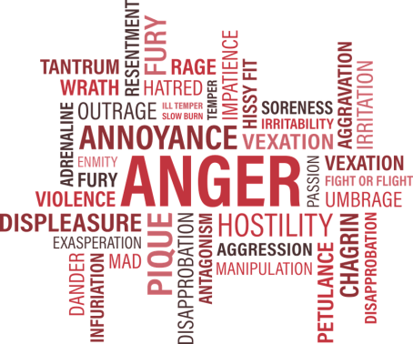
Brighton and Hove Clinic
10 Top Tips for Anger Management

1. Recognising the signs – Your heart may beat quicker, your breathing may be shallow, you may experience tension in your chest and shoulders, and you may clench your fists. Be aware of what your body is telling you, recognise these symptoms. All humans have physical reactions to anger.
2. Control your breathing – Focus on your breathing and breath out for longer than breathing in. When you are angry, you automatically breathe in much more than you are breathing out. Thus reversing the breathing (breathing out for longer) you are calming yourself down which will allow you to think clearer.
3. Count to 10 – By counting to 10, you are giving yourself distance to the situation that angers you, which allows you think more clearly. Preventing you from acting on your impulses and lashing out.
4. Exercise – Swimming, running, cycling, and walking are only a few of the different types of exercises you can implement to lower your stress levels, which in turn will reduce your irritation and anger.
5. Self-care & relax – Make time regularly to relax and make sure you are getting enough sleep. When we are not well rested, tired, and under pressure we have a “shorter fuse” and are much more likely to act on our feelings of anger.
6. Stay away from drugs and alcohol – Using drugs and alcohol as a way of coping with your feelings, will not help you in the long run. They lower your inhibitions, and actually we do need our inhibitions to stop us from acting upon our impulses.
7. Creativity & hobbies – Painting, writing, dancing, playing instruments are all activities that release tension and thus lower your feelings of anger.
8. Notice your thoughts – When a situation occurs that evokes anger in you, notice what your thoughts are in that moment. “She is always late”, “You never support me”, “He should listen to what I’m saying” – using language such as always, never, should, shouldn’t, must, mustn’t etc. creates unreasonable expectations and can lead to tension and anger.
9. Talk! – Talking about a situation that angered you with a friend can help you reflect upon what happened. It allows you to get a different perspective on the event, and lets you let off some steam.
10. Seek Professional Help - If you have taken all the steps above and made positive lifestyle changes but still find that you are unable to manage your anger, seek professional help. Anger can be managed and you can feel better.

At the Brighton and Hove Clinic we understand that accessing help for your anger problems can be frightening so our team of experts are here to support you through this journey in making the best treatment decisions for your particular issues. We have a comprehensive range of treatments available; the first step in accessing treatment is for our expert team to carry out a comprehensive assessment with you and create a bespoke treatment programme that is tailored to your needs.

If you would like to know more about the services at the Brighton & Hove clinic or you would like to book an appointment, please call our Relationship Manager Sophia Jaques on 07387417022 or email sophia.jaques@elysiumhealthcare.co.uk

