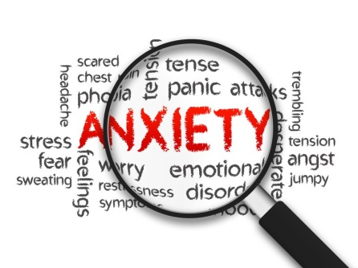
Brighton and Hove Clinic
Top 10 Tips for Anxiety

1. Don't suppress your anxiety
Trying to suppress anxiety or push it away is likely to be counterproductive. Everyone experiences anxiety. It is a normal response to stress. Let it in when it shows up. Practice acceptance. Rather than trying to push it away (which tends to be futile, resulting in feeling more overwhelmed and less in control), make room for anxiety.
2. Breathe
Deep diaphragmatic breathing is a powerful anxiety-reducing technique because it activates the body’s relaxation response. It helps the body go from the fight-or-flight response of the sympathetic nervous system to the relaxed response of the parasympathetic nervous system
3. Focus on the here and now
Usually when we get anxious our mind is throwing up scenarios in the future which are unlikely to happen. Instead, pause, breathe and pay attention to what’s happening right now. Even if something serious is happening, focusing on the present moment will improve your ability to manage the situation.
4. Use a brief mindfulness exercise
Picture yourself on a river bank or outside in a favorite park, field or beach. Watch leaves pass by on the river or clouds pass by in the sky. Assign [your] emotions, thoughts [and] sensations to the clouds and leaves, and just watch them float by.
This is very different from what people typically do. Typically, we assign emotions, thoughts and physical sensations certain qualities and judgments, such as good or bad, right or wrong. This often amplifies anxiety. Remember that “it is all just information.”
5. Limit alcohol and caffeine
Although alcohol may temporarily reduce anxiety, when it wears off there is often a rebound effect which increases anxiety levels. Self- medicating for anxiety with alcohol in this way also prevents us learning coping skills and can be a short-cut to developing alcohol dependence. Caffeine can cause increased heart rate and other symptoms which can be interpreted as anxiety.
6. Exercise
Exercise is one of the most effective treatments for anxiety. Movement and activity promote blood flow, improve neurotransmitter production and regulation, calm anxiety symptoms and much more. Some people find Tai Chi or yoga particularly effective whereas others prefer a hard workout at the gym or a run.
7. Eat healthily
Many people find changing to a healthy diet improves symptoms of anxiety. High levels of sugar and processed food may increase symptoms whereas getting a good supply of B vitamins and omega 3 fatty acids may be helpful.
8. Laugh
Laughing produces endorphins and helps us to connect with others. Both of these can switch off our brains threat activation system and promote feelings of safety.

9. Try not to avoid
Try not to avoid situations which cause anxiety, particularly if this limits activities which would otherwise be life enriching. Avoidance increases our level of anticipatory anxiety over time and prevents us from learning how to cope.
10. Seek professional help
If you have taken all the steps above and made positive lifestyle changes but still find that your anxiety is getting worse seek professional help. There are a number of effective treatments for anxiety disorders which can help you feel better and engage with life more effectively.

At the Brighton and Hove Clinic we understand that accessing help for anxiety can be frightening so our team of experts are here to support you through this journey in making the best treatment decisions for your particular issues. We have a comprehensive range of treatments available; the first step in accessing treatment is for our expert team to carry out a comprehensive assessment with you and create a bespoke treatment programme that is tailored to your needs.

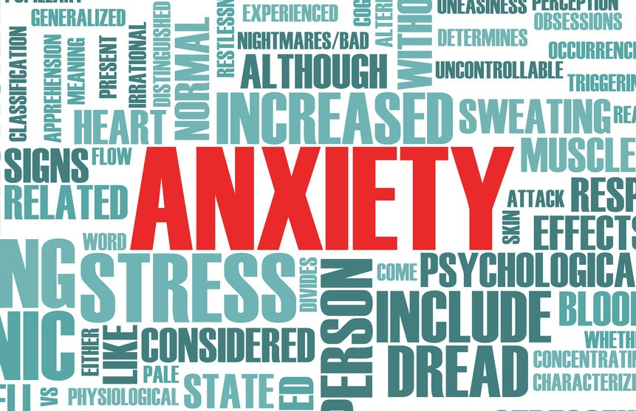
If you would like to know more about the services at the Brighton & Hove clinic or you would like to book an appointment, please call our Relationship Manager Sophia Jaques on 07387417022 or email sophia.jaques@elysiumhealthcare.co.uk

