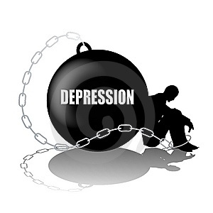
Brighton and Hove Clinic
Top 10 Tips for Depression

1: Regular sleep – It may be hard to get enough sleep or have too much sleep when we are depressed. Not enough sleep can make depression worse. Have a set sleep routine; go to bed and wake at the same time.
2: Eat a healthy diet – Food intake tends to increase or decrease when we are depressed. Being mindful of what you eat and monitoring any change in appetite could be beneficial. Ensure that you are eating a healthy, balanced diet.
3: Exercise/be more active – exercise produces more endorphins in your body; a chemical that makes you feel good. Regular exercise has long term positive benefits on people.
4: Talk to family/friends – When we are depressed we have a tendency to withdraw and isolate from friends and family. Try to identify who makes you feel safe, supported and cared for and talk to them. Social and family supports are essential to aide recovery with depression.
5: Challenge negative thinking – When we are depressed we seem to have a mental filter that allows us to see only negatives in life. Challenge the negative thinking you come across and ask yourself where the evidence for the negative is.
6: Do something new – When we are depressed we tend to avoid things; we become reluctant to do regular day to day activities and anything new appears daunting. It may be beneficial to push yourself to do something different, something new.
7: Take on responsibilities – We tend to pull away from all responsibilities and give up on life when we are depressed. Try to stay involved in everyday activities at home and at work because responsibility will help you maintain activities that can counter depression.
9: Reduce alcohol/caffeine – Alcohol and caffeine are psychoactive drugs which affect the brain function resulting in a change in mood, thinking, behaviour, perception and consciousness. Long term use of alcohol and caffeine alters our brain chemistry and mood ultimately becomes more unstable which makes the symptoms of depression worse.
10: Seek professional help – If you have taken all the steps above and made positive lifestyle changes but still find that your depression is getting worse seek professional help. Depression can be treated and you can feel better.

At the Brighton and Hove Clinic we understand that accessing help for depression can be frightening so our team of experts are here to support you through this journey in making the best treatment decisions for your particular issues. We have a comprehensive range of treatments available; the first step in accessing treatment is for our expert team to carry out a comprehensive assessment with you and create a bespoke treatment programme that is tailored to your needs.

If you would like to know more about the services at the Brighton & Hove clinic or you would like to book an appointment, please call our Relationship Manager Sophia Jaques on 07387417022 or email sophia.jaques@elysiumhealthcare.co.uk

