Your diabetes annual review care plan
Thank you for coming to the surgery for your diabetes annual review. Your results are shown below.

What you need to do now
It is important that we discuss these results together so we can help you plan your care to stay healthy in the year ahead. To make sure we are putting your needs at the centre of this process, please complete Your Goals sheet and bring it with you at your next appointment. Website advice available as shown.

Please remember to bring the following to your appointment:

- any medication you take including any you may take for other health problems
- this care plan and completed ‘ Your Goals’ section
- blood glucose meter (if you have one)
- blood sugar result book (if you have one)
 | Blood glucose  The HbA1c figure gives us an idea of your overall blood glucose levels over the past 3 months. Keeping your blood glucose levels under control can help lower your risk of future complications. |  |  | Your HbA1c (mmol/mol)  Better below 58mmol/mol
 | Blood pressure  High blood pressure can put you at greater risk of having a heart attack or stroke |  |  | Your Blood pressure  Better below 140/80 (or 130/80  if you have heart or kidney disease)
 | Cholesterol  Cholesterol is a fat in the blood. Eating healthy fats in small portions as well as taking a statin tablet can limit the risk of heart disease. |  |  | Your Cholesterol (mmol/L)  Better below 4  Or  As long as you are on a higher dose of an effective statin
 | Eyes  Diabetic retinopathy is a complication of diabetes and can cause blindness if not treated. This may be prevented if any changes in your eyes are detected early enough. Your retinal screening test will be done at a venue local to you. You will receive an appointment letter from the NHS Retinal Screening Service. |  |  | Refer to your Diabetic eye screening result and discuss any concerns with your nurse.
 | Feet  We examine your feet to check the blood flow and that there is no damage to your nerves or skin.  https://cop.org.uk/foot-health/diabetes/  https://www.diabetes.org.uk/guide-to-diabetes/complications/feet |  |  | Your Last Foot Check
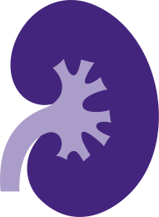 | Kidneys  We test your kidneys using a blood test and a urine test. Diabetes can damage the kidneys. We measure how well they are working to identify any problems at an early stage so that we can try to minimise further damage. |  |  | GFR calculated abbreviated MDRD :
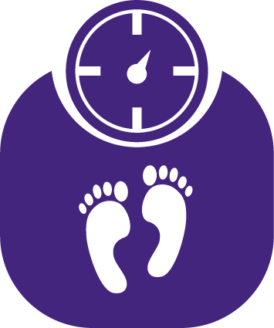 | Weight and diet  Being overweight increases the risk of many medical conditions including heart disease and arthritis and can make your HbA1c, blood pressure and cholesterol more difficult to control. Weight, especially around the middle, can cause insulin resistance. BMI is a way of looking at your weight adjusted for your height. |  |  | Your BMI  BMI  Weight  Better between 19 and 25  https://www.bda.uk.com/foodfacts/home
 | Low mood  Some people with diabetes feel low in mood and/or experience anxiety. We’d like to try to help if you’re experiencing this or you may wish to find out about Talking Health, the Depression and Anxiety Service. |  |  | Time to Talk available contact details on our website at www.moatfield.co.uk
 | Flu vaccination  People with diabetes should be vaccinated as they are at greater risk of severe illness, such as pneumonia, if they get flu. |  |  | 22-Sep-2016 Seasonal influenza vaccination :
 | Erectile dysfunction  Erectile dysfunction is a common problem amongst men who have diabetes so please talk to us about it. |  |  | https://www.nhs.uk/live-well/sexual-health/male-sexual-problems/
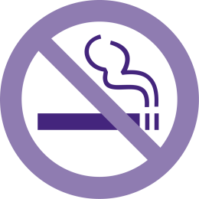 | Smoking  Smoking causes many problems with your health, but is particularly damaging in people with diabetes.  Stopping smoking is the single most important thing you can do. |  |  | https://www.nhs.uk/live-well/quit-smoking/nhs-stop-smoking-services-help-you-quit/
 | Alcohol  If you drink too much alcohol, this will raise your blood pressure over time. In addition, alcohol contains a lot of calories which can make you gain weight and as a result increase your blood pressure. |  |  | Your recorded alcohol intake (units/week)  https://www.drinkaware.co.uk/alcohol-facts/health-effects-of-alcohol/effects-on-the-body/alcohol-and-blood-pressure/
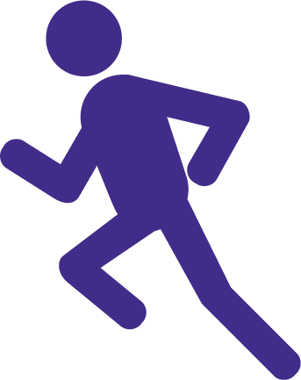 | Activity  Regular activity will improve your health and wellbeing. This can be anything from walking, gardening, washing the car, house work to running, swimming and cycling. |  |  | https://www.nhs.uk/live-well/exercise/free-fitness-ideas/
Medication

If you have started a new medication for your diabetes you are eligible for extra help and advice from your local pharmacist.
These are some of the things people often want to talk about related to their diabetes.
Mark those which you feel you would like to discuss or have some help with when we meet.
Blood Sugar  Weight & Diet  Low mood  Erectile Dysfunction |  | Exercise  Feet  Family concerns  Feeling tired all the time |  |  | Medical check-ups  Smoking  Taking medication  Thinking of getting pregnant

Your Goals

Your diabetes plan:

What is important to you in managing your health?

What aspects of your life may help you to manage your diabetes?

What aspects of your life may make it difficult for you to manage your diabetes?
(including difficulties with low mood, anxiety or stress)

Two things I will focus on between now and my next appointment:

- I would like to

because

- I would like to

because

More information to help manage your diabetes is available

Websites www.diabetes.org.uk and www.nhs.uk/conditions/diabetes

Your next appointment with the practice will be:

