Looking after yourself – Your healthy lifestyle care plan
 | Blood pressure  High blood pressure can put you at greater risk of having a heart attack or stroke | Your Blood pressure:  Better below 140/90 (or 130/80  if you have heart or kidney disease)
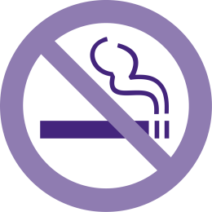 | Smoking  Smoking causes many problems with your health, including your heart and lungs, but also contributing to problems such as erectile dysfunction.  Stopping smoking is the single most important thing you can do for your health and wellbeing. | For local services visit Mid-Sussex Wellbeing  https://www.nhs.uk/live-well/quit-smoking/nhs-stop-smoking-services-help-you-quit/
 | Cholesterol  Cholesterol is a fat in the blood. Eating healthy fats in small portions as well as taking a statin tablet can limit the risk of heart disease. | Your Cholesterol: mmol/L  Better below 4  https://www.nhs.uk/conditions/high-cholesterol/how-to-lower-your-cholesterol/
 | Alcohol  Drinking too much alcohol is associated with an increased risk of many conditions from heart and liver disease to cancer. In addition, alcohol contains a lot of calories which can make you gain weight. | Your recorded alcohol intake (units/week)  For local services visit Mid-Sussex Wellbeing  https://www.drinkaware.co.uk/alcohol-facts/health-effects-of-alcohol/effects-on-the-body/alcohol-and-blood-pressure/
 | Caffeine  Excess caffeine will also raise your blood pressure. Caffeine is present in many foods and drinks. Excessive caffeine consumption should be reduced slowly to reduce withdrawal effects such as headaches | https://www.nhs.uk/conditions/high-blood-pressure-hypertension/prevention/

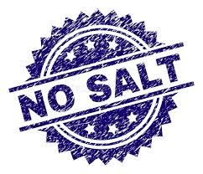 | Salt  There is a lot of salt already in many daily food items. Salt raises your blood pressure. Reducing salt intake can significantly improve your blood pressure | https://www.nhs.uk/live-well/eat-well/salt-nutrition/
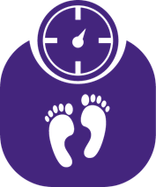 | Weight and diet  Being overweight increases the risk of many medical conditions including heart disease, diabetes and arthritis, as well as making your blood pressure and cholesterol more difficult to control. BMI is a way of looking at your weight adjusted for your height. | Your Weight  Your BMI  Better between 19 and 25  For local services visit Mid-Sussex Wellbeing  https://www.bda.uk.com/resource/weight-loss.html
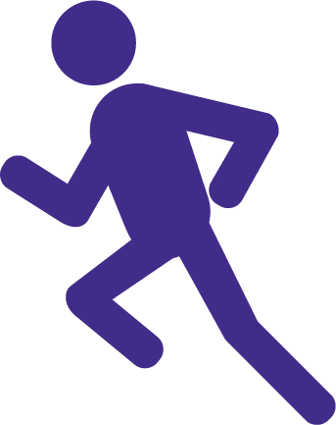 | Activity  Regular activity will improve your health and wellbeing. This can be anything from walking, gardening, washing the car, housework to running, swimming & cycling We can also provide exercise on prescription, please contact the surgery. | View the government recommended levels of activity here.  For local services visit Mid-Sussex Wellbeing  https://www.nhs.uk/live-well/exercise/free-fitness-ideas/
 | Erectile dysfunction  Erectile dysfunction is a common problem amongst men especially those with certain long term conditions, so please talk to us about it. | https://www.nhs.uk/live-well/sexual-health/male-sexual-problems/
 | Low mood  Many people may have times in their life where they feel low in mood and/or experience anxiety. We’d like to try to help if you’re experiencing this or you may wish to find out about Time To Talk, the Depression and Anxiety Service. | Time To Talk

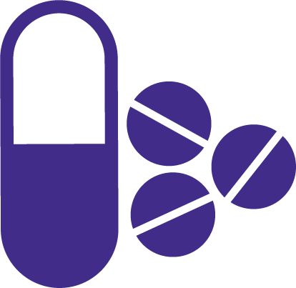 | Medication  If you are started on a new medication, you may be eligible for extra help and advice from your local pharmacist when you collect your first prescription.
 | Medication costs  Taking multiple medications can be expensive. If you receive 13 or more prescriptions per year you can save money with a prepayment certificate | https://www.nhs.uk/using-the-nhs/help-with-health-costs/
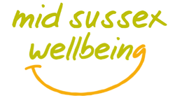 | Mid-Sussex Wellbeing  Can help you to find local wellbeing information and services. You can also get support for things like getting fitter, doing some regular exercise, dealing with stress, kicking a habit, or simply improving your general wellbeing.
The following section can help you in working towards a more healthier lifestyle.
My goals

My healthy lifestyle care plan:

What is important to you in managing your health?

What aspects of your life may help you to improve your lifestyle?

What aspects of your life may make it difficult for you to improve your lifestyle?
(including difficulties with low mood, anxiety or stress)

Factors that I will focus on:

- I would like to

because

- I would like to

because

