Your hypertension (high blood pressure) annual review care plan
Thank you for working with us on your blood pressure management plan. Your results are shown below.
What you need to do now
It is important that we discuss these results with you so we can help you plan your care to stay healthy in the years ahead. To make sure we are putting your needs at the centre of this process, please complete Your Goals sheet and bring it with you at your next appointment. Website advice available as shown.

Please remember to bring the following to your telephone / online / surgery appointment:

- any medication you take including any you may take for other health problems
- this care plan and completed ‘ Your Goals’ section
- your blood pressure diary
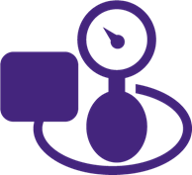 | Blood pressure  High blood pressure can put you at greater risk of having a heart attack or stroke | Your Blood pressure:  Better below 140/90 (or 130/80  if you have heart or kidney disease)
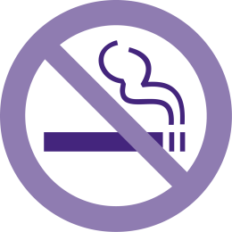 | Smoking  Smoking causes many problems with your health, but is particularly damaging in people with high blood pressure.  Stopping smoking is the single most important thing you can do. | For local services visit Mid-Sussex Wellbeing  https://www.nhs.uk/live-well/quit-smoking/nhs-stop-smoking-services-help-you-quit/
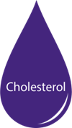 | Cholesterol  Cholesterol is a fat in the blood. Eating healthy fats in small portions as well as taking a statin tablet can limit the risk of heart disease. | Your Cholesterol: mmol/L  Better below 4  https://www.nhs.uk/conditions/high-cholesterol/how-to-lower-your-cholesterol/
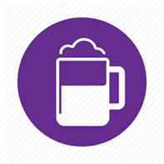 | Alcohol  If you drink too much alcohol, this will raise your blood pressure over time. In addition, alcohol contains a lot of calories which can make you gain weight and as a result increase your blood pressure. | Your recorded alcohol intake (units/week)  For local services visit Mid-Sussex Wellbeing  https://www.drinkaware.co.uk/alcohol-facts/health-effects-of-alcohol/effects-on-the-body/alcohol-and-blood-pressure/

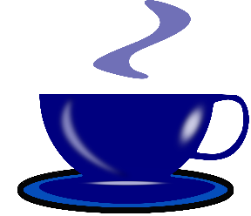 | Caffeine  Excess caffeine will also raise your blood pressure. Caffeine is present in many foods and drinks. Excessive caffeine consumption should be reduced slowly to reduce withdrawal effects such as headaches |  |  | https://www.nhs.uk/conditions/high-blood-pressure-hypertension/prevention/
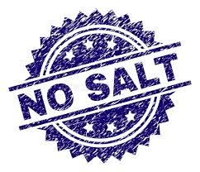 | Salt  There is a lot of salt already in many daily food items. Salt raises your blood pressure. Reducing salt intake can significantly improve your blood pressure |  |  | https://www.nhs.uk/live-well/eat-well/salt-nutrition/
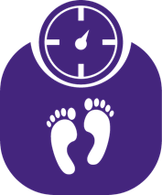 | Weight and diet  Being overweight increases the risk of many medical conditions including heart disease and arthritis and can make your blood pressure and cholesterol more difficult to control. Weight, especially around the middle, can increase your risk of diabetes. BMI is a way of looking at your weight adjusted for your height. |  |  | Your Weight  Your BMI  Better between 19 and 25  For local services visit Mid-Sussex Wellbeing  https://www.bda.uk.com/resource/weight-loss.html
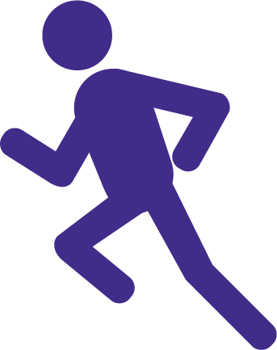 | Activity  Regular activity will improve your health and wellbeing. This can be anything from walking, gardening, washing the car, housework to running, swimming & cycling. |  |  | View the government recommended levels of activity here.  For local services visit Mid-Sussex Wellbeing  https://www.nhs.uk/live-well/exercise/free-fitness-ideas/
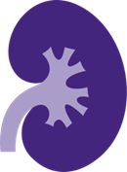 | Kidneys  Some medications and/or background condition require a blood test to check your kidneys. High blood pressure can damage the kidneys. We measure how well they are working to identify any problems at an early stage so that we can try to minimise further damage. |  |  | Kidney function blood result (if any)  GFR  (normally over 60)
 |  | Erectile dysfunction  Erectile dysfunction is a common problem amongst men who have high blood pressure so please talk to us about it. | https://www.nhs.uk/live-well/sexual-health/male-sexual-problems/
 |  | Low mood  Some people with hypertension feel low in mood and/or experience anxiety. We’d like to try to help if you’re experiencing this or you may wish to find out about Time To Talk, the Depression and Anxiety Service. | Time To Talk
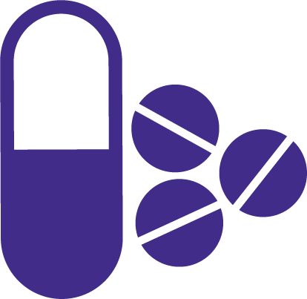 |  | Medication  If you are started on a new medication for your blood pressure, you are eligible for extra help and advice from your local pharmacist when you collect your first prescription.
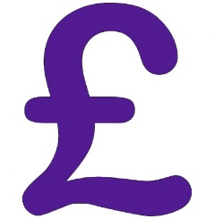 |  | Medication costs  Taking multiple medications can be expensive. If you receive 13 or more prescriptions per year you can save money with a prepayment certificate | https://www.nhs.uk/using-the-nhs/help-with-health-costs/
Mid-Sussex Wellbeing

Can help you to find local wellbeing information and services. You can also get support for things like getting fitter, doing some regular exercise, dealing with stress, kicking a habit, or simply improving your general wellbeing.
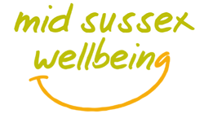

These are some of the things people often want to talk about related to their high blood pressure.
Mark those which you feel you would like to discuss or have some help with when we meet.
Exercise  Weight & Diet  Low mood  Erectile Dysfunction | Taking medication  Smoking  Family concerns  Feeling tired | Medical check-ups  Thinking of getting pregnant  Long-term risks  Other (specify) ___________
Your Goals

Your hypertension care plan:

What is important to you in managing your health?

What aspects of your life may help you to manage your hypertension?

What aspects of your life may make it difficult for you to manage your hypertension?
(including difficulties with low mood, anxiety or stress)

Two things I will focus on between now and my next appointment:

- I would like to

because

- I would like to

because

More information to help manage your hypertension is available

Websites: www.nhs.uk/conditions/high-blood-pressure-hypertension

Your next appointment with the practice will be:

